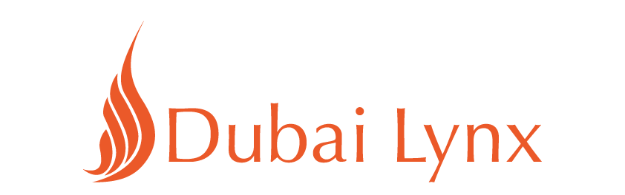

DUBAI LYNX SPECIAL AWARDS

Network of the Year
- Leo Burnett
- McCannWorldgroup
- Y&R

Agency of the Year
- Leo Burnett Beirut
- FP7/DXB, Dubai
- Y&R, Dubai

Media Agency of the Year
- Starcom MediaVest Group, Dubai
- UM MENA, Dubai
- Mediacom MENA, Dubai

Independent Agency of the Year
- Republique, Beirut
- Kairo, Cairo
- Buzzman Middle East, Dubai

Lynx Palm
- Déjà vu, Dubai
- Lighthouse Films, Cairo
- Stoked, Beirut

